**Table 1. Baseline patient and tumor characteristics for the internal and external validation set.**

|  |  |  |  |  |  |  |
| --- | --- | --- | --- | --- | --- | --- |
|  | **Europe (N=4071)** | **Center A (N=983)** | **Center B (N=1343)** | **Center C (N=566)** | **Center D (N=1179)** | **Validation (N=4822)** |
| **Positive SN status** | 889 (21.8%) | 236 (24.0%) | 259 (19.3%) | 170 (30.0%) | 224 (19.0%) | 891 (18.5%) |
| **Males** | 1996 (49.0%) | 497 (50.6%) | 753 (56.1%) | 273 (48.2%) | 473 (40.1%) | 2857 (59.2%) |
| **Age** |  |  |  |  |  |  |
| Median (Q1, Q3) | 55.0 (43.0, 66.0) | 55.0 (43.0, 65.0) | 62.0 (48.0, 71.0) | 52.0 (40.0, 62.0) | 51.0 (42.0, 62.0) | 58.0 (46.0, 68.0) |
| Min - Max | 13.0 - 94.0 | 15.0 - 89.0 | 13.0 - 94.0 | 13.0 - 88.0 | 15.0 - 83.0 | 5.0 - 94.0 |
| **Ulceration** | 1171 (28.8%) | 265 (27.0%) | 263 (19.6%) | 166 (29.3%) | 477 (40.5%) | 1298 (26.9%) |
| Missing | 141 (3.5%) | 30 (3.1%) | 31 (2.3%) | 68 (12.0%) | 12 (1.0%) | 279 (5.8%) |
| **Location** |  |  |  |  |  |  |
| Arm | 615 (15.1%) | 128 (13.0%) | 217 (16.2%) | 86 (15.2%) | 184 (15.6%) | 893 (18.5%) |
| Leg | 1189 (29.2%) | 277 (28.2%) | 324 (24.1%) | 218 (38.5%) | 370 (31.4%) | 1238 (25.7%) |
| Trunk | 1815 (44.6%) | 407 (41.4%) | 654 (48.7%) | 242 (42.8%) | 512 (43.4%) | 1855 (38.5%) |
| Head/neck | 314 (7.7%) | 138 (14.0%) | 142 (10.6%) | 20 (3.5%) | 14 (1.2%) | 836 (17.3%) |
| Missing | 138 (3.4%) | 33 (3.4%) | 6 (0.4%) | 0 (0.0%) | 99 (8.4%) | 0 (0.0%) |
| **Histology** |  |  |  |  |  |  |
| SSM | 2164 (53.2%) | 598 (60.8%) | 910 (67.8%) | 285 (50.4%) | 371 (31.5%) | 1982 (41.1%) |
| NM | 1226 (30.1%) | 276 (28.1%) | 290 (21.6%) | 195 (34.5%) | 465 (39.4%) | 1562 (32.4%) |
| ALM | 126 (3.1%) | 29 (3.0%) | 54 (4.0%) | 16 (2.8%) | 27 (2.3%) | 89 (1.8%) |
| Other | 202 (5.0%) | 53 (5.4%) | 46 (3.4%) | 14 (2.5%) | 89 (7.5%) | 561 (11.6%) |
| Missing | 353 (8.7%) | 27 (2.7%) | 43 (3.2%) | 56 (9.9%) | 227 (19.3%) | 628 (13.0%) |
| **Breslow** |  |  |  |  |  |  |
| Mean (SD) | 2.8 (3.3) | 2.6 (2.0) | 2.3 (2.5) | 2.8 (2.3) | 3.6 (4.9) | 2.7 (2.4) |
| Min - Max | 0.1 - 90.0 | 0.5 - 22.0 | 0.1 - 30.0 | 0.3 - 20.0 | 0.1 - 90.0 | 0.6 - 47.0 |
| Missing | 59 (1.4%) | 9 (0.9%) | 16 (1.2%) | 6 (1.1%) | 28 (2.4%) | 0 (0.0%) |
| **Multiple fields** | 374 (9.2%) | 223 (22.7%) | 41 (3.1%) | 87 (15.4%) | 23 (2.0%) | - |
| **Total number of negative SN** |  |  |  |  |  |  |
| Median (Q1, Q3) | 1.0 (1.0, 2.0) | 1.0 (1.0, 2.0) | 1.0 (1.0, 2.0) | 1.0 (1.0, 1.0) | 2.0 (1.0, 3.0) | 2.0 (1.0, 3.0) |
| Min - Max | 0.0 - 15.0 | 0.0 - 15.0 | 0.0 - 13.0 | 0.0 - 10.0 | 0.0 - 9.0 | 0.0 - 17.0 |
| Missing | 162 (4.0%) | 0 (0.0%) | 27 (2.0%) | 1 (0.2%) | 134 (11.4%) | 0 (0.0%) |
| **Total number of positive SN** |  |  |  |  |  |  |
| Median (Q1, Q3) | 0.0 (0.0, 0.0) | 0.0 (0.0, 1.0) | 0.0 (0.0, 0.0) | 0.0 (0.0, 0.0) | 0.0 (0.0, 0.0) | 0.0 (0.0, 0.0) |
| Min - Max | 0.0 - 5.0 | 0.0 - 4.0 | 0.0 - 2.0 | 0.0 - 4.0 | 0.0 - 5.0 | 0.0 - 8.0 |
| Missing | 1 (0.0%) | 0 (0.0%) | 1 (0.1%) | 0 (0.0%) | 0 (0.0%) | 0 (0.0%) |
| **SN tumour burden** |  |  |  |  |  |  |
| Mean (SD) | 1.2 (1.3) | 1.1 (0.8) | 1.0 (0.5) | 1.1 (1.3) | 1.4 (2.0) | 1.2 (1.4) |
| Min - Max | 0.0 - 38.0 | 0.0 - 8.0 | 0.0 - 8.0 | 0.0 - 15.0 | 0.0 - 38.0 | 0.0 - 23.0 |
| Missing | 301 (7.4%) | 120 (12.2%) | 163 (12.1%) | 18 (3.2%) | 0 (0.0%) | 153 (3.2%) |
| **Location metastasis lymph** |  |  |  |  |  |  |
| Subcap1 | 3319 (81.5%) | 793 (80.7%) | 1123 (83.6%) | 440 (77.7%) | 963 (81.7%) | 4270 (88.6%) |
| Combined | 213 (5.2%) | 39 (4.0%) | 27 (2.0%) | 43 (7.6%) | 104 (8.8%) | - |
| Parenchymal | 86 (2.1%) | 5 (0.5%) | 11 (0.8%) | 19 (3.4%) | 51 (4.3%) | - |
| Multifocal | 45 (1.1%) | 6 (0.6%) | 9 (0.7%) | 21 (3.7%) | 9 (0.8%) | - |
| Extensive | 105 (2.6%) | 18 (1.8%) | 10 (0.7%) | 25 (4.4%) | 52 (4.4%) | - |
| Not subcap | - | - | - | - | - | 379 (7.9%) |
| Missing | 303 (7.4%) | 122 (12.4%) | 163 (12.1%) | 18 (3.2%) | 0 (0.0%) | 173 (3.6%) |
| **Mitosis > 1 mm2** | 135 (3.3%) | 50 (5.1%) | 0 (0.0%) | 85 (15.0%) | 0 (0.0%) | 206 (4.3%) |
| Missing | 3895 (95.7%) | 906 (92.2%) | 1343 (100.0%) | 467 (82.5%) | 1179 (100.0%) | 0 (0.0%) |
| **Median time to recurrence in years (Q1, Q3)** | 4.87 [2.29; 7.77] | 4.82 [2.99; 6.94] | 2.69 [0.93; 5.52] | 6.47 [3.65; 9.65] | 6.49 [3.62; 10.19] | 4.84 [2.16; 8.67] |
| **Median follow-up time in years (Q1, Q3)** | 4.79 [2.28; 7.76] | 4.75 [2.97; 6.96] | 2.73 [0.94; 5.56] | 6.33 [3.53; 9.60] | 6.19 [3.37; 10.12] | 5.02 [2.23; 8.91] |

1Subcap also includes single-cell. Abbreviations: Q1, first quantile (Q1); Q3, third quantile; SD, standard deviation; SN, sentinel node, SSM, superficial spreading melanoma; NM, nodular melanoma; ALM, acral lentiginous melanoma.

**5-year Kaplan-Meier estimates (i.e., take into account censoring) on development and validation data**

|  |  |  |  |  |  |  |  |  |  |  |  |  |  |  |  |  |  |
| --- | --- | --- | --- | --- | --- | --- | --- | --- | --- | --- | --- | --- | --- | --- | --- | --- | --- |
|  |  | | Development data | | | | | |  |  | | Validation data | | | | | |
|  |  |  | | # in first 5 years | |  | Kaplan-Meier at 5 years | |  |  |  | | # in first 5 years | |  | Kaplan-Meier at 5 years | |
| Patients | N |  | | Recurrence | MSM |  | Recurrence | MSM |  | N |  | | Recurrence | MSM |  | Recurrence | MSM |
| All | 4,071 |  | | 792 | 403 |  | 24.5 | 13.5 |  | 4,822 |  | | 1,086 | 567 |  | 29.1 | 16.7 |
| Negative | 3,182 |  | | 344 | 196 |  | 18.0 | 8.9 |  | 3,931 |  | | 434 | 266 |  | 22.9 | 11.7 |
| Positive | 889 |  | | 448 | 207 |  | 48.7 | 30.9 |  | 891 |  | | 652 | 301 |  | 53.2 | 34.5 |

**Discriminative ability of recurrence of the AJCC7, AJCC8, and the developed prediction model for all patients, only patients with positive sentinel node(s), or only patients with negative sentinel node(s) in the development data.**

|  |  |  |  |  |  |
| --- | --- | --- | --- | --- | --- |
|  | AJCC7 | |  | AJCC8 | |
|  | C-index | CI |  | C-index | CI |
| All patients | 0.73 | [0.72; 0.75] |  | 0.74 | [0.72; 0.75] |
| Negative SN status | 0.71 | [0.69; 0.74] |  | 0.71 | [0.69; 0.74] |
| Positive SN status | 0.58 | [0.55; 0.60] |  | 0.62 | [0.59; 0.64] |

Abbreviations: AJCC, American Joint Committee on Cancer; CI, 95% confidence interval; SN, sentinel node.

**Discriminative ability of recurrence of the AJCC7, AJCC8, and the developed prediction model for all patients, only patients with positive sentinel node(s), or only patients with negative sentinel node(s) in the validation data.**

|  |  |  |  |  |  |  |  |  |  |  |  |  |  |  |
| --- | --- | --- | --- | --- | --- | --- | --- | --- | --- | --- | --- | --- | --- | --- |
|  | Prediction model | |  | AJCC7 | |  | Model vs AJCC7 | |  | AJCC8 | |  | Model vs AJCC8 | |
|  | C-index | CI |  | C-index | CI |  | Diff | CI |  | C-index | CI |  | Diff | CI |
| All patients | 0.74 | [0.72; 0.75] |  | 0.71 | [0.70; 0.73] |  | 0.02 | [0.02; 0.03] |  | 0.71 | [0.70; 0.73] |  | 0.03 | [0.02; 0.03] |
| Negative SN status | 0.69 | [0.67; 0.71] |  | 0.66 | [0.64; 0.69] |  | 0.02 | [0.01; 0.03] |  | 0.66 | [0.64; 0.68] |  | 0.03 | [0.02; 0.04] |
| Positive SN status | 0.68 | [0.66; 0.71] |  | 0.60 | [0.58; 0.63] |  | 0.08 | [0.06; 0.10] |  | 0.62 | [0.59; 0.64] |  | 0.07 | [0.05; 0.09] |

Abbreviations: AJCC, American Joint Committee on Cancer; CI, 95% confidence interval; SN, sentinel node.

**In text:** Association between linear predictors of recurrence and MSM was even stronger / was of the same size (calibration slope: 1.13 [1.02; 1.24]).

**Table 2. Final model predicting the probability of recurrence after a sentinel node procedure.** Table displays hazard ratios and the 95% confidence intervals of the Cox proportional hazards model predicting the probability of recurrence. The model is selected using backward selection with p-values < 0.01.

|  |  |  |  |  |  |  |
| --- | --- | --- | --- | --- | --- | --- |
|  | **Negative SN** | | **Positive SN** | | **Importance** | |
|  | **HR** | **CI** | **HR** | **CI** | **Main** | **Int.** |
| **Positive SN status** |  |  | 2.93 | [2.44; 3.52] | 138 |  |
| **Age**  (i.q.r. 66 versus 43 years) | 1.21 | [1.08; 1.35] | 1.21 | [1.08; 1.35] | 11 |  |
| **Ulceration** | 1.60 | [1.36; 1.88] | 1.60 | [1.36; 1.88] | 32 |  |
| **Location** |  |  |  |  | 19 |  |
| Arm | (ref) |  | (ref) |  |  |  |
| Leg | 1.30 | [0.99; 1.69] | 1.30 | [0.99; 1.69] |  |  |
| Trunk | 1.46 | [1.13; 1.88] | 1.46 | [1.13; 1.88] |  |  |
| Head and neck | 1.98 | [1.44; 2.72] | 1.98 | [1.44; 2.72] |  |  |
| **Breslow** **thickness**  (i.q.r. 3.5 versus 1.2 mm) | 2.57 | [2.26; 2.93] | 1.59 | [1.34; 1.88] | 218 | 21 |
| **SN tumour burden** |  |  | 5.15 | [2.51; 10.59] | 20 |  |
| *C-index1* | 0.76 | [0.75; 0.78] |  |  |  |  |
| *C-index recalibrated MSM1* | 0.79 | [0.77; 0.81] |  |  |  |  |

1The C-index is corrected for optimism. Abbreviations: SN, sentinel node; HR, hazard ratio; CI, 95% confidence interval; Importance, defined by the Chi-square Wald-statistic; Main, the Wald-statistic for the main effect; Int., the Wald-statistic for the interaction term with positive SN-status.

**Figure 1a. Nomogram to determine the score associated with certain patient characteristics.** To calculate the probability of melanoma-specific mortality and recurrence draw a line straight up to the point’s axis to determine the score associated with that age. Repeat the process for every indicated variable. Sum the scores for each factor and locate sum on X-axis of Figure 1b to obtain the probability of recurrence and melanoma-specific mortality 5-years after the sentinel node procedure on the y-axis.

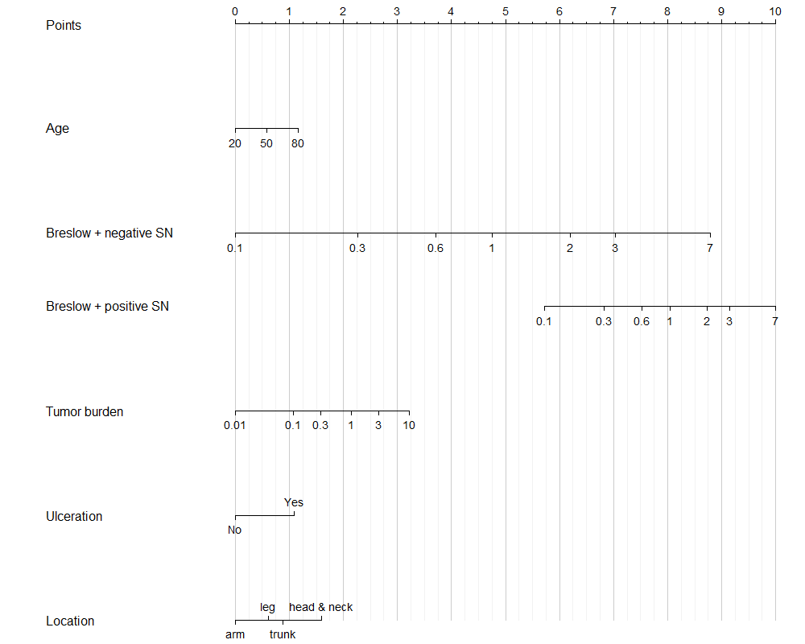

Abbreviations: SN, Sentinel Node.

**Figure 1b. Risk distribution and the probability of recurrence and melanoma-specific mortality 5 years after the sentinel node procedure.** The curves refer to the predicted probability of recurrence or melanoma-specific mortality 5 years after the sentinel node procedure. The histogram refers to the risk score distribution in the cohort; each bar represents the proportion of patients in the cohort that was assigned that specific score.

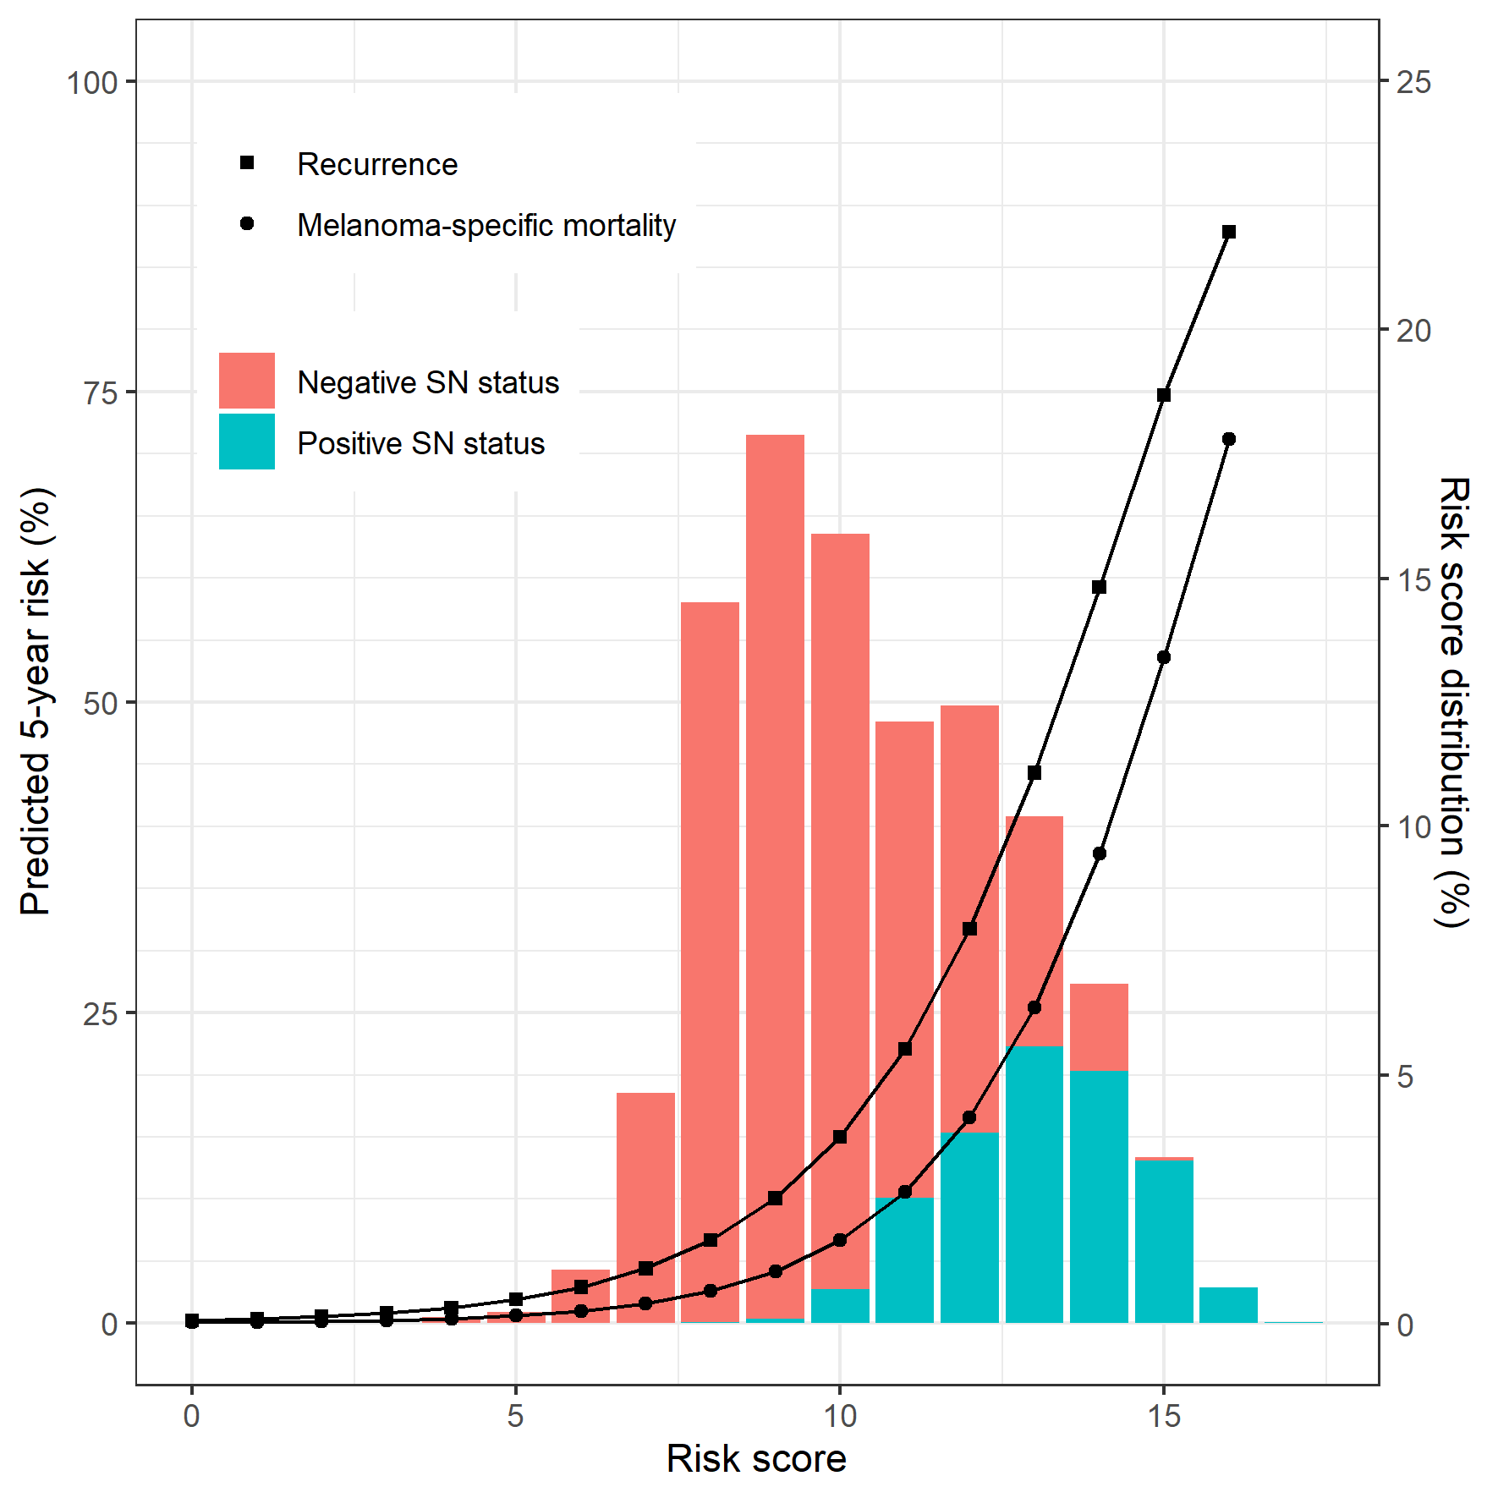

**Figures 2a. Calibration of the developed model predicting recurrence after a sentinel node procedure for all Australian patients, only patients with positive SN, only patients with negative SN, obtained using the model developed on the European data.** The calibration intercept (a), calibration slope (b), and C-index were computed for each imputed development data set and averaged.

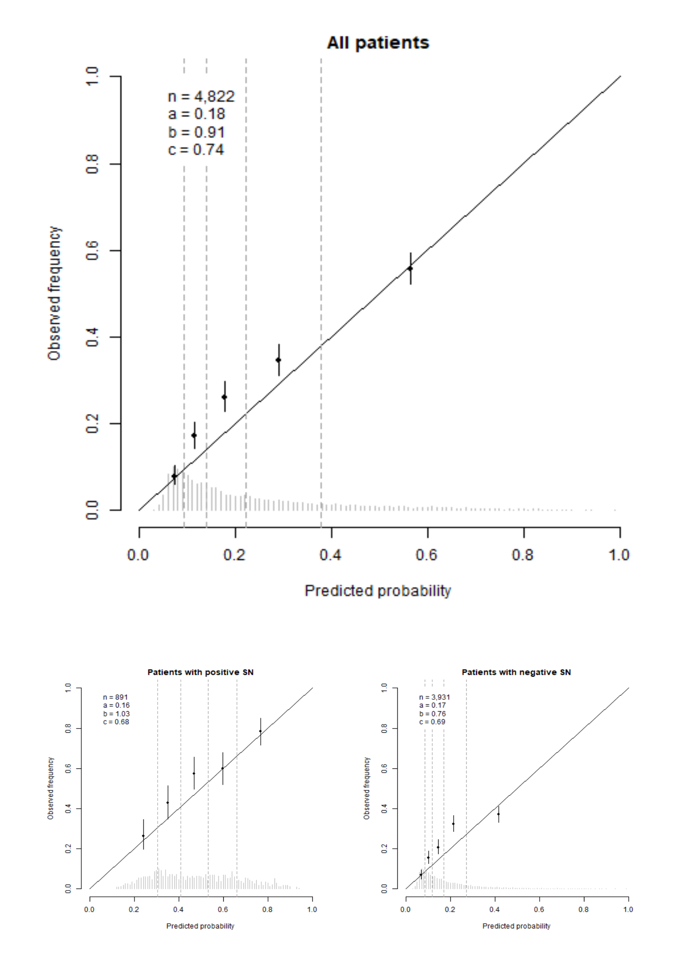

**Figure 2b. Calibration of the developed model predicting melanoma-specific mortality after a sentinel node procedure for all Australian patients, only patients with positive SN, only patients with negative SN, obtained using the model developed on the European data.** The calibration intercept (a), calibration slope (b), and C-index were computed for each imputed development data set and averaged.

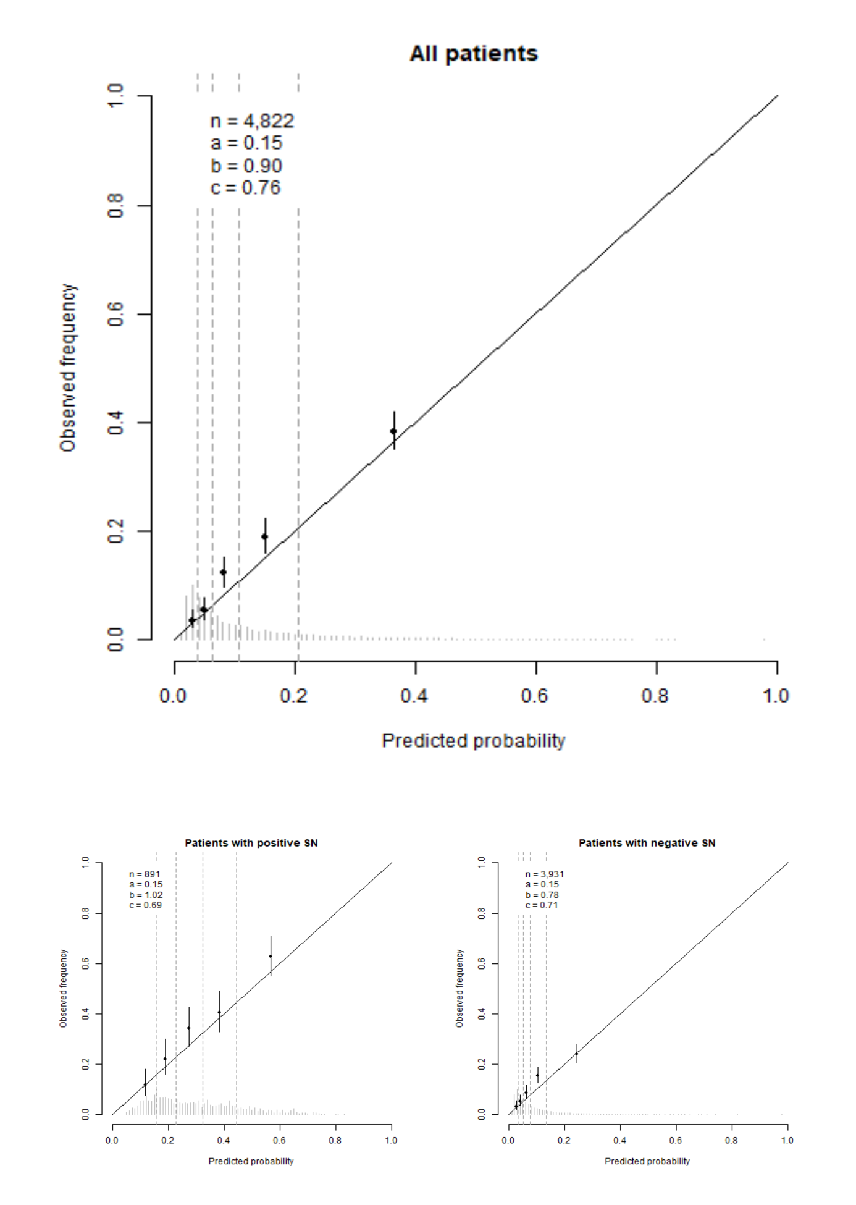

**SUPPLEMENT**

The date of recurrence was missing for 45 (1.1%) patients in the development data and 58 (1.2%) patients in the validation data, whilst it was indicated that recurrence did occur within the follow-up period. In the development data, the majority of these patients were from centre D (42 patients), two patients from centre B, and one patient from centre A. The time-to-recurrence for these patients was imputed using single imputation.

**Table S1. Refitted final model predicting the probability of melanoma-specific mortality after a sentinel node procedure.** Table displays hazard ratios and the 95% confidence intervals of the Cox proportional hazards model predicting the probability of melanoma-specific mortality. The model is selected using backward selection with p-values < 0.01.

|  |  |  |  |  |  |  |
| --- | --- | --- | --- | --- | --- | --- |
|  | **Negative** | | **Positive** | | **Importance** | |
|  | **HR** | **CI** | **HR** | **CI** | **Main** | **Int.** |
| **Positive SN status** |  |  | 3.40 | [2.61; 4.43] | 87 |  |
| **Age**  (i.q.r. 66 versus 43 years) | 1.18 | [1.00; 1.38] | 1.18 | [1.00; 1.38] | 4 |  |
| **Ulceration** | 1.83 | [1.47; 2.28] | 1.83 | [1.47; 2.28] | 30 |  |
| **Location** |  |  |  |  | 16 |  |
| Arm | (ref) |  | (ref) |  |  |  |
| Leg | 0.96 | [0.66; 1.41] | 0.96 | [0.66; 1.41] |  |  |
| Trunk | 1.44 | [1.00; 2.06] | 1.44 | [1.00; 2.06] |  |  |
| Head and neck | 1.74 | [1.10; 2.74] | 1.74 | [1.10; 2.74] |  |  |
| **Breslow** **thickness**  (i.q.r. 3.5 versus 1.2 mm) | 2.78 | [2.30; 3.36] | 1.60 | [1.27; 2.01] | 123 | 14 |
| **SN tumour burden** |  |  | 7.27 | [2.65; 19.94] | 15 |  |
| *C-index1* | 0.79 | [0.77; 0.81] |  |  |  |  |

1The C-index is corrected for optimism. Abbreviations: SN, sentinel node; HR, hazard ratio; CI, 95% confidence interval; Importance, defined by the Chi-square Wald-statistic; Main, the Wald-statistic for the main effect; Int., the Wald-statistic for the interaction term with positive SN-status.

**Figure S1. Calibration of the final model predicting recurrence for all patients, only patients with positive SN, and only patients with negative SN from all centres in the development data with positive and negative sentinel nodes.** The calibration intercept (a), calibration slope (b), and C-index were computed for each imputed development data set and averaged, but not corrected for optimism.

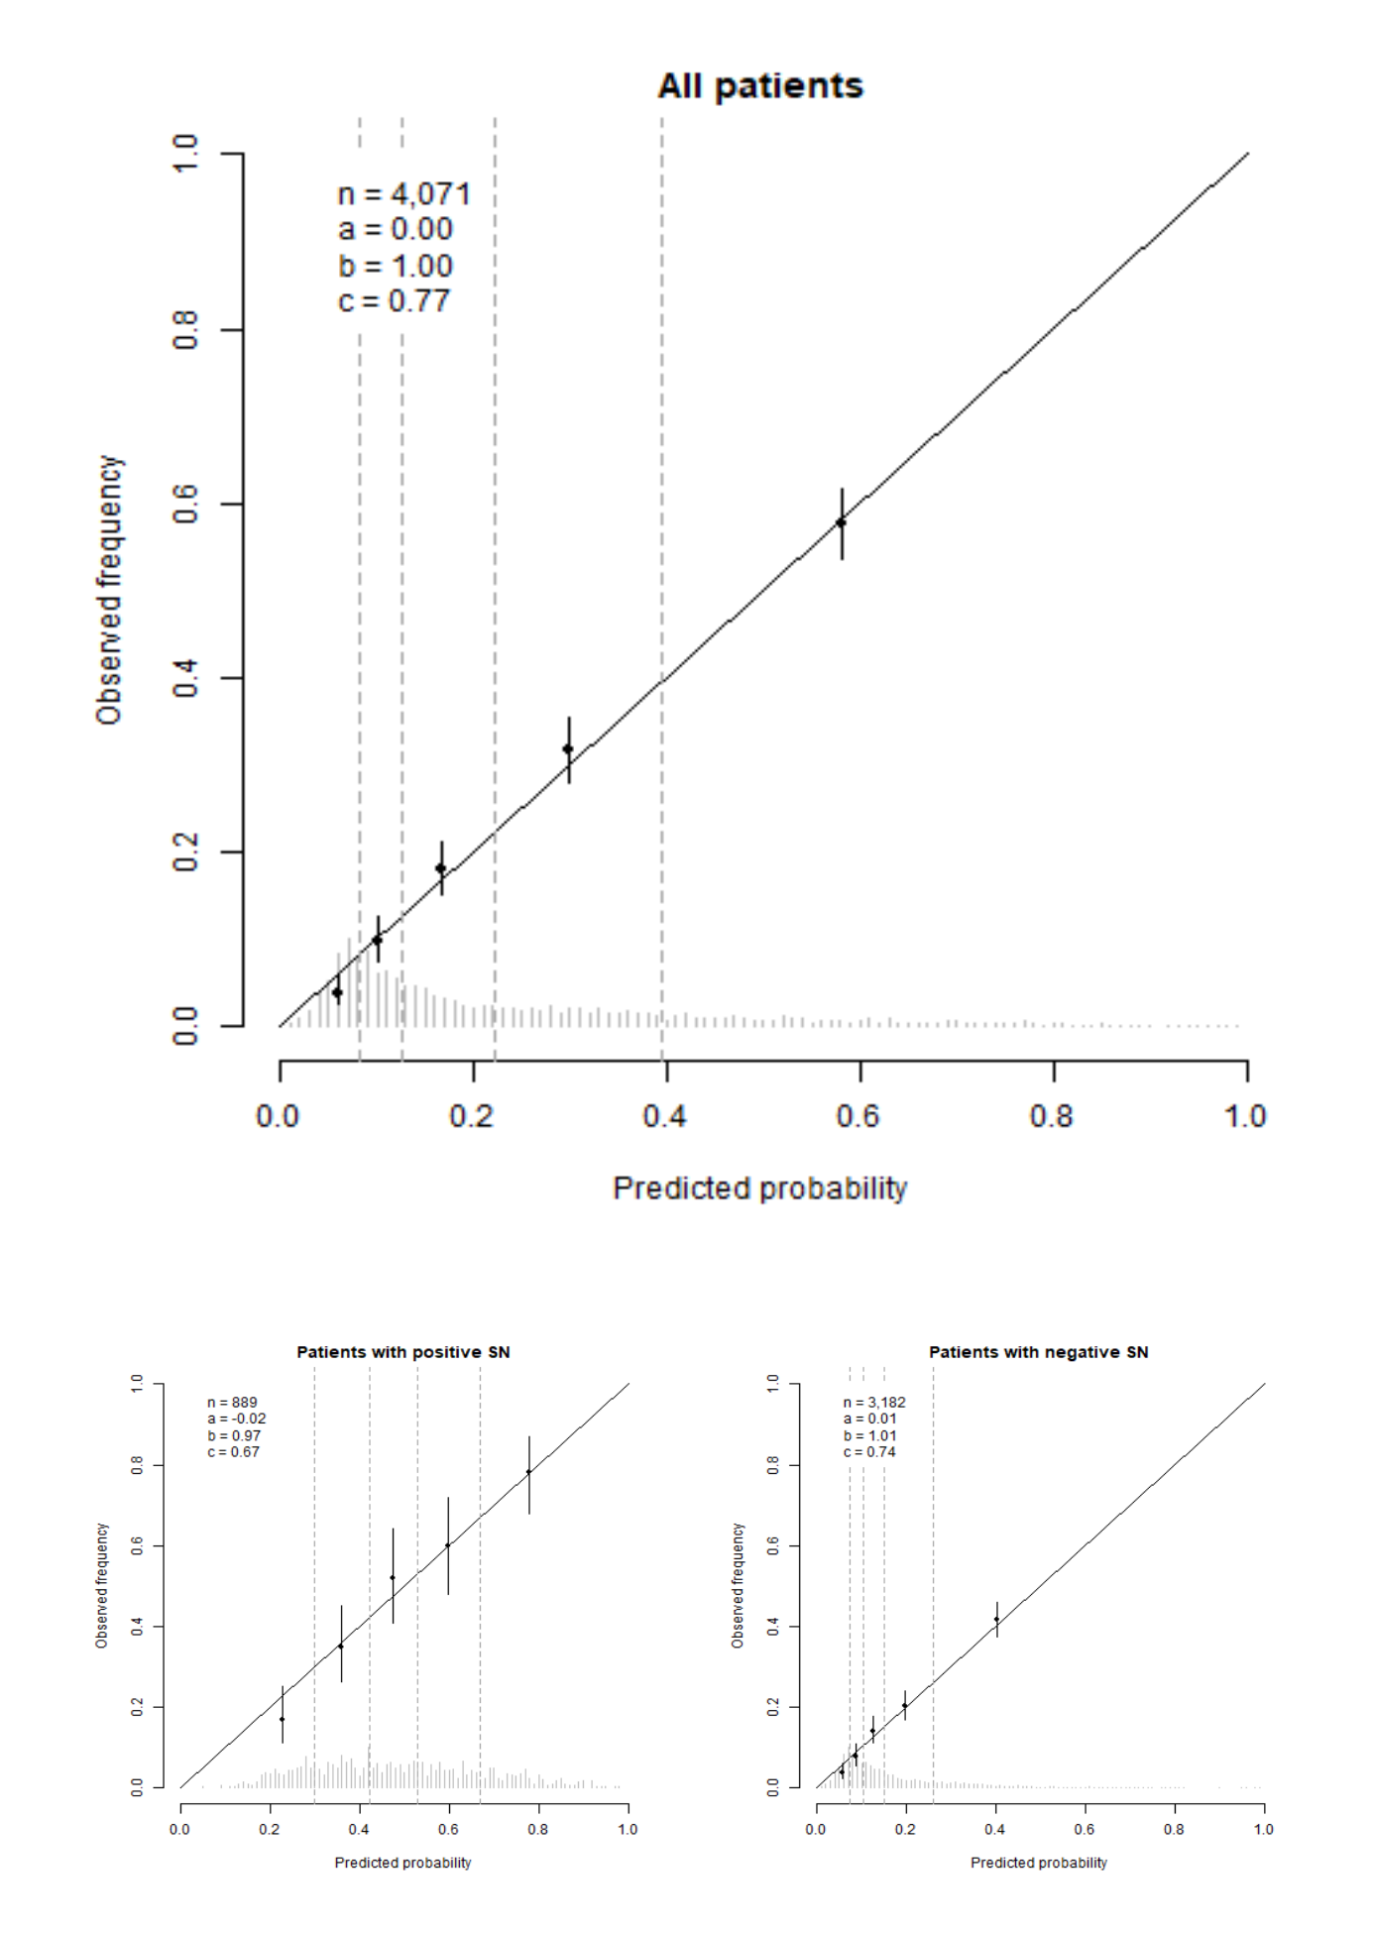

**Figure S2. Calibration of the final model predicting melanoma-specific mortality for all patients, only patients with positive SN, and only patients with negative SN from all centres in the development data with positive and negative sentinel nodes.** The calibration intercept (a), calibration slope (b), and C-index were computed for each imputed development data set and averaged, but not corrected for optimism.

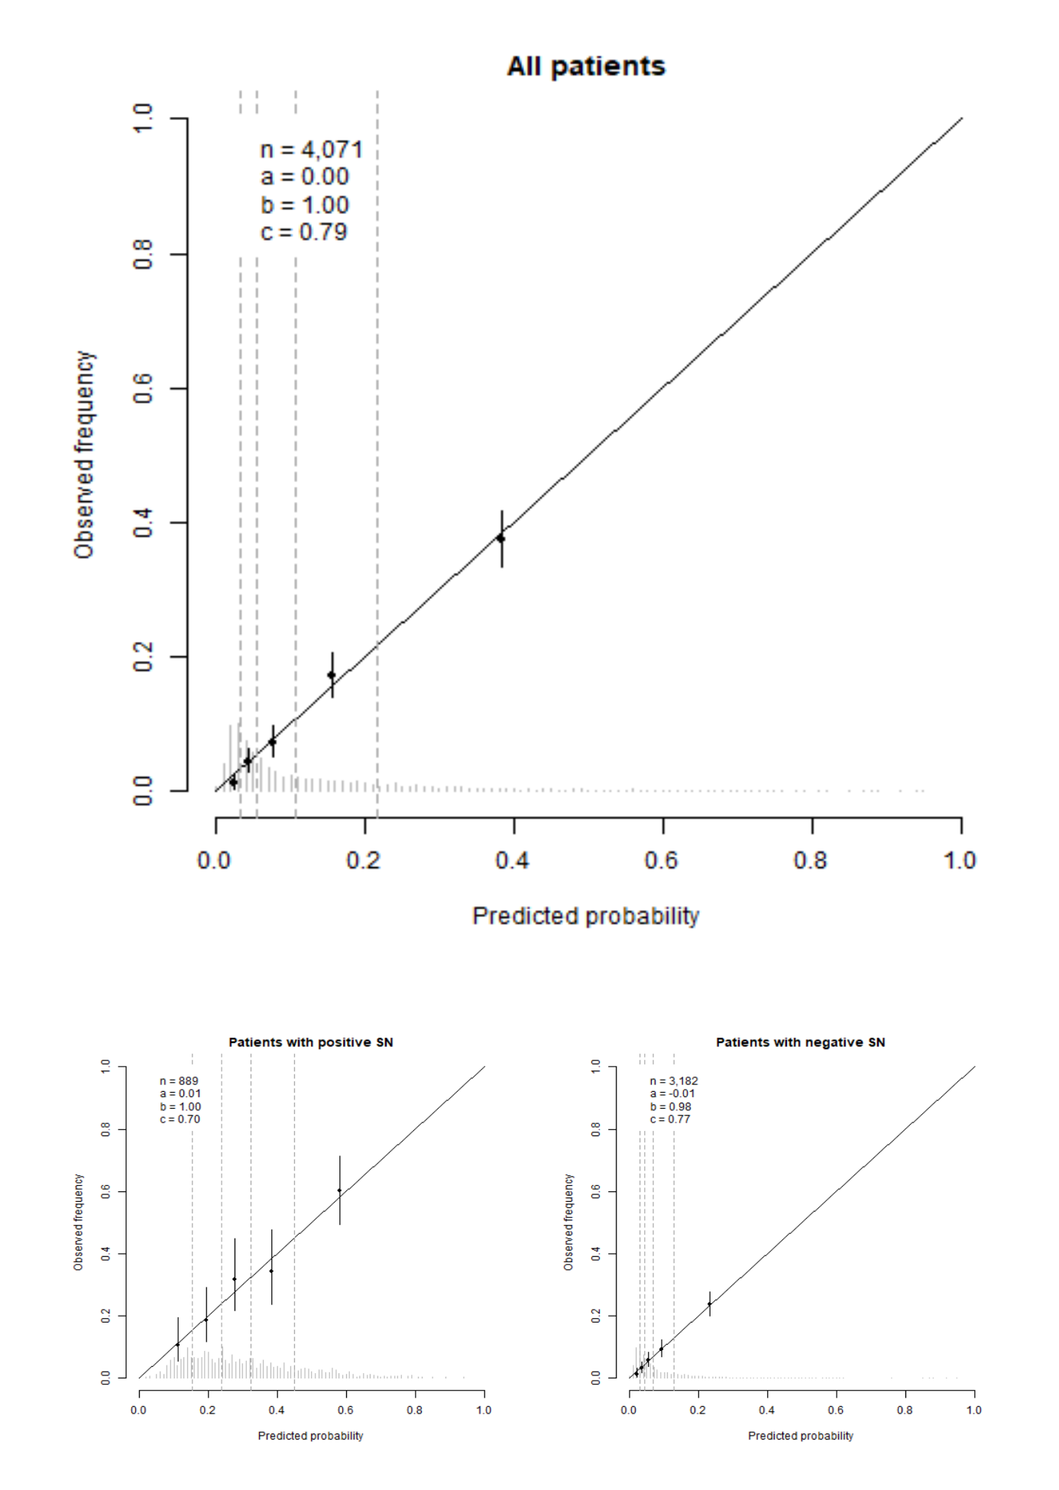

**Figure S3. Calibration of the final model predicting recurrence for each centre separately for patients in the development data.** Calibration is obtained using leave-one-centre-out internal-external validation. The calibration intercept (a), calibration slope (b), and C-index were computed for each imputed development data set and averaged, but not corrected for optimism.

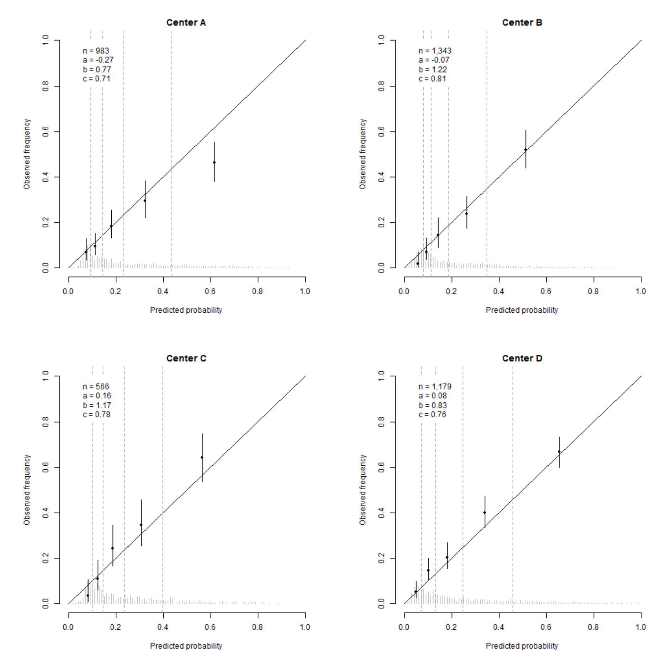

**Figure S4. Calibration of the final calibrated model predicting melanoma-specific mortality for each centre separately for all patients in the development data.** Calibration is obtained using leave-one-centre-out internal-external validation. The calibration intercept (a), calibration slope (b), and C-index were computed for each imputed development data set and averaged, but not corrected for optimism.

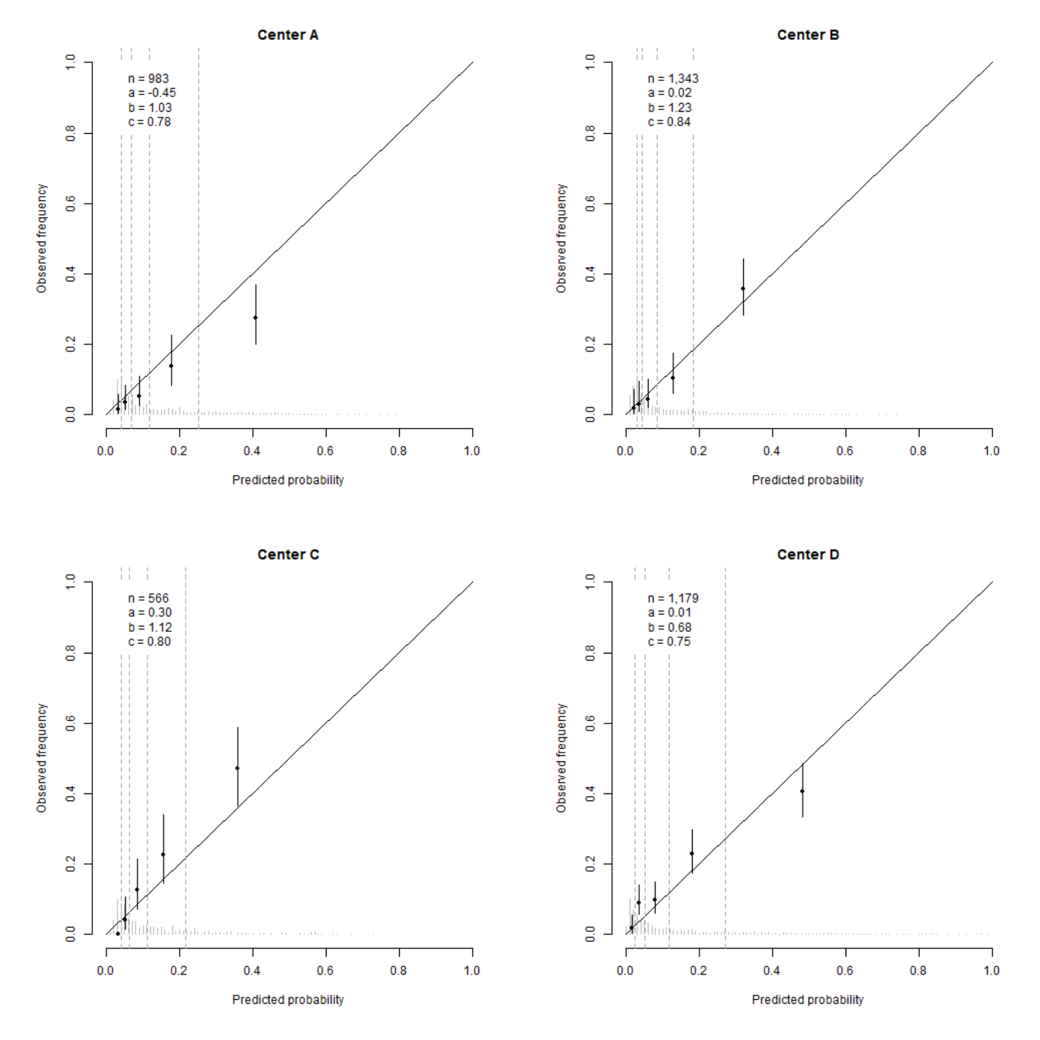

**NOT USED**

**Table. Average number of patients in each class of AJCC7 and AJCC8 of the five imputed data sets.**

|  |  |  |  |  |  |
| --- | --- | --- | --- | --- | --- |
|  | Development data | |  | Validation data | |
| Class | AJCC7 | AJCC8 |  | AJCC7 | AJCC8 |
| IA | 217 | 253 |  | 369 | 0 |
| IB | 1,532 | 1,496 |  | 1,570 | 1,940 |
| IIA | 692 | 692 |  | 1,068 | 1,068 |
| IIB | 495 | 495 |  | 663 | 663 |
| IIC | 250 | 250 |  | 261 | 261 |
| IIIA | 471 | 199 |  | 530 | 247 |
| IIIB | 407 | 208 |  | 351 | 191 |
| IIIC | 8 | 476 |  | 10 | 450 |
| IIID1 | 0 | 4 |  | 0 | 3 |

1Class IIID is not a class defined by the AJCC7.

**Table. Full model predicting 5-year recurrence**. This Table displays the hazard ratios together with the 95 percent confidence intervals of the full Cox proportional hazards model predicting 5-year recurrence.

|  |  |  |  |  |  |  |
| --- | --- | --- | --- | --- | --- | --- |
|  | **Negative SN** | | **Positive SN** | | **Importance** | |
|  | **HR** | **CI** | **HR** | **CI** | **Main** | **Int.** |
| **Positive SN status1** |  |  | 4.02 | [2.04; 7.92] | 41 | 25 |
| **Male** | 1.25 | [1.03; 1.53] | 0.98 | [0.78; 1.23] | 5 | 3 |
| **Age**  (i.q.r. 66 versus 43 years) | 1.11 | [0.96; 1.29] | 1.29 | [1.08; 1.53] | 10 | 2 |
| **Ulceration** | 1.65 | [1.33; 2.05] | 1.40 | [1.10; 1.78] | 28 | 1 |
| **Location** |  |  |  |  | 20 | 1 |
| Arm | (ref) |  | (ref) |  |  |  |
| Leg | 1.44 | [1.05; 1.98] | 1.08 | [0.62; 1.90] |  |  |
| Trunk | 1.50 | [1.10; 2.05] | 1.14 | [0.66; 1.96] |  |  |
| Head and neck | 2.33 | [1.57; 3.46] | 1.53 | [0.80; 2.92] |  |  |
| **Histology** |  |  |  |  | 10 | 0 |
| SSM | (ref) |  | (ref) |  |  |  |
| NM | 1.30 | [1.03; 1.64] | 1.29 | [0.99; 1.68] |  |  |
| ALM | 1.43 | [0.83; 2.45] | 1.39 | [0.80; 2.40] |  |  |
| Other | 1.00 | [0.64; 1.57] | 1.15 | [0.50; 2.66] |  |  |
| **Breslow** **thickness**  (i.q.r. 3.5 versus 1.2 mm) | 2.40 | [2.06; 2.80] | 1.56 | [1.30; 1.88] | 147 | 12 |
| **Multiple fields** | 1.52 | [1.10; 2.10] | 1.46 | [1.05; 2.02] | 11 | 0 |
| **Total number of negative nodes** | 0.95 | [0.90; 1.01] | 0.95 | [0.90; 1.01] | 3 |  |
| **Total number of positive nodes** |  |  | 0.98 | [0.82; 1.17] | 0 |  |
| **SN tumour burden**  (i.q.r. 38 versus 0.01) |  |  | 3.61 | [1.30; 10.00] | 6 |  |
| **Location metastasis in lymph node** |  |  |  |  | 6 |  |
| Subcap |  |  | (ref) |  |  |  |
| Combined |  |  | 1.40 | [0.93; 2.10] |  |  |
| Parenchymal |  |  | 0.96 | [0.58; 1.60] |  |  |
| Multifocal |  |  | 0.90 | [0.52; 1.55] |  |  |
| Extensive |  |  | 1.22 | [0.74; 2.02] |  |  |
| *C-index2* | 0.77 | [0.75; 0.78] |  |  |  |  |
| *C-index recalibrated MSM2* | 0.79 | [0.77; 0.81] |  |  |  |  |

1The hazard ratio of positive sentinel node patients includes the effects from the interaction terms. 2The C-index is corrected for optimism. Abbreviations: SN, sentinel node; HR, hazard ratio; CI, 95 percent confidence interval; Importance defined by the chi-square Wald-statistic; Main the Wald-statistic for the main effect of the coefficient; Int., the Wald-statistic for the interaction term with positive SN status; SSM, superficial spreading melanoma; NM, nodular melanoma; ALM, acral lentiginous melanoma; MSM, melanoma specific mortality.

**Table. Refitted full model predicting 5-year melanoma specific mortality**. This Table displays the hazard ratios together with the 95 percent confidence intervals of the refitted full Cox proportional hazards model predicting 5-year melanoma specific mortality.

|  |  |  |  |  |  |  |
| --- | --- | --- | --- | --- | --- | --- |
|  | **Negative SN** | | **Positive SN** | | **Importance** | |
|  | **HR** | **CI** | **HR** | **CI** | **Main** | **Int.** |
| **Positive SN status1** |  |  | 6.44 | [2.54; 16.31] | 38 | 30 |
| **Male** | 1.65 | [1.22; 2.24] | 1.21 | [0.89; 1.64] | 12 | 2 |
| **Age**  (i.q.r. 66 versus 43 years) | 0.93 | [0.74; 1.16] | 1.39 | [1.09; 1.76] | 8 | 6 |
| **Ulceration** | 2.06 | [1.51; 2.80] | 1.64 | [1.20; 2.24] | 30 | 1 |
| **Location** |  |  |  |  | 15 | 4 |
| Arm | (ref) |  | (ref) |  |  |  |
| Leg | 1.13 | [0.69; 1.83] | 0.86 | [0.44; 1.69] |  |  |
| Trunk | 1.80 | [1.15; 2.81] | 0.94 | [0.48; 1.83] |  |  |
| Head and neck | 1.81 | [0.97; 3.37] | 1.56 | [0.75; 3.28] |  |  |
| **Histology** |  |  |  |  | 5 | 1 |
| SSM | (ref) |  | (ref) |  |  |  |
| NM | 1.36 | [0.95; 1.93] | 1.14 | [0.83; 1.59] |  |  |
| ALM | 1.51 | [0.63; 3.64] | 1.27 | [0.59; 2.76] |  |  |
| Other | 1.00 | [0.48; 2.07] | 0.71 | [0.16; 3.06] |  |  |
| **Breslow** **thickness**  (i.q.r. 3.5 versus 1.2 mm) | 2.54 | [2.02; 3.18] | 1.58 | [1.24; 2.01] | 76 | 8 |
| **Multiple fields** | 1.22 | [0.76; 1.97] | 1.49 | [0.98; 2.27] | 4 | 0 |
| **Total number of negative nodes** | 0.94 | [0.86; 1.03] | 0.94 | [0.86; 1.03] | 2 |  |
| **Total number of positive nodes** |  |  | 0.99 | [0.79; 1.25] | 0 |  |
| **SN tumour burden**  (i.q.r. 38 versus 0.01) |  |  | 4.74 | [1.11; 20.25] | 4 |  |
| **Location metastasis in lymph node** |  |  |  |  | 2 |  |
| Subcap |  |  | (ref) |  |  |  |
| Combined |  |  | 1.08 | [0.66; 1.76] |  |  |
| Parenchymal |  |  | 1.23 | [0.63; 2.37] |  |  |
| Multifocal |  |  | 1.19 | [0.60; 2.34] |  |  |
| Extensive |  |  | 1.42 | [0.74; 2.72] |  |  |
| *C-index2* | 0.80 | [0.78; 0.82] |  |  |  |  |

1The hazard ratio of positive sentinel node patients includes the effects from the interaction terms. 2The C-index is corrected for optimism. Abbreviations: SN, sentinel node; HR, hazard ratio; CI, 95 percent confidence interval; Importance defined by the chi-square Wald-statistic; Main the Wald-statistic for the main effect of the coefficient; Int., the Wald-statistic for the interaction term with positive SN status; SSM, superficial spreading melanoma; NM, nodular melanoma; ALM, acral lentiginous melanoma.

**Figure. Calibration curves of the final model predicting recurrence for each centre only for positive sentinel node patients obtained using leave-one-out internal-external validation.**

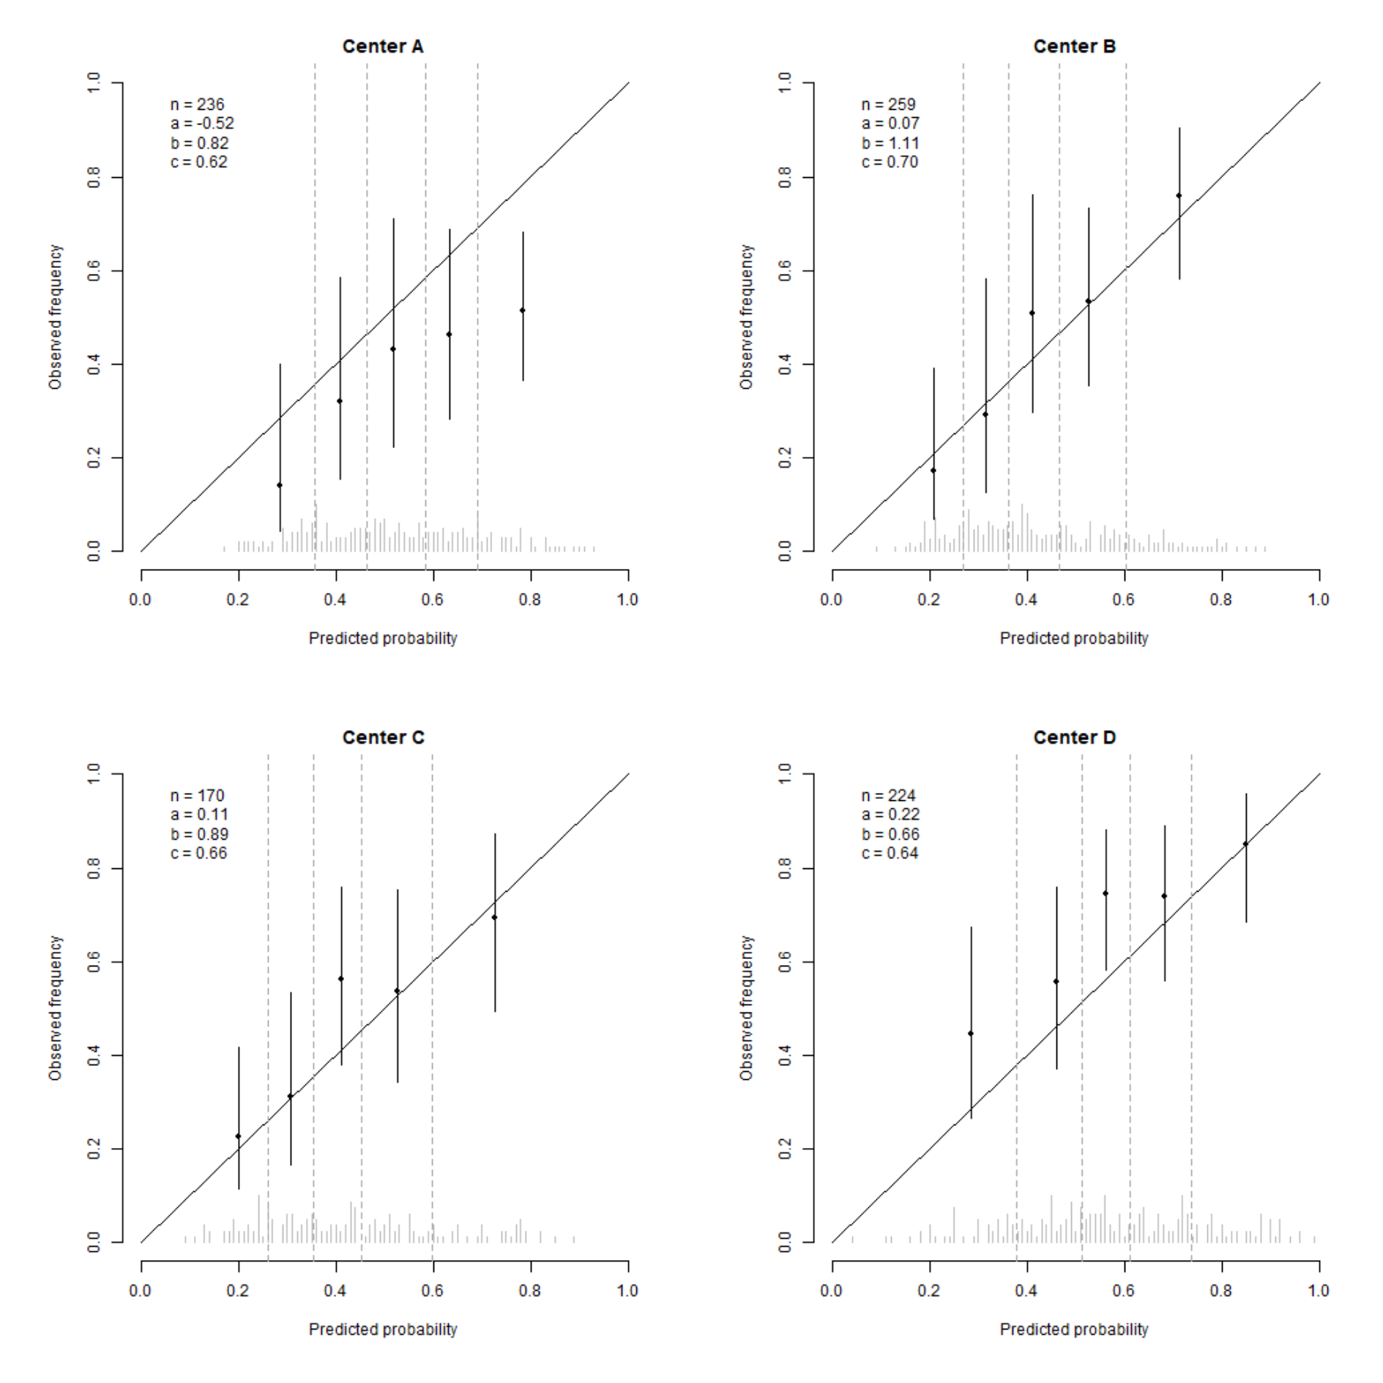

**Figure. Calibration curves of the final calibrated model predicting melanoma specific mortality for each centre only for positive sentinel node patients obtained using leave-one-out internal-external validation.**

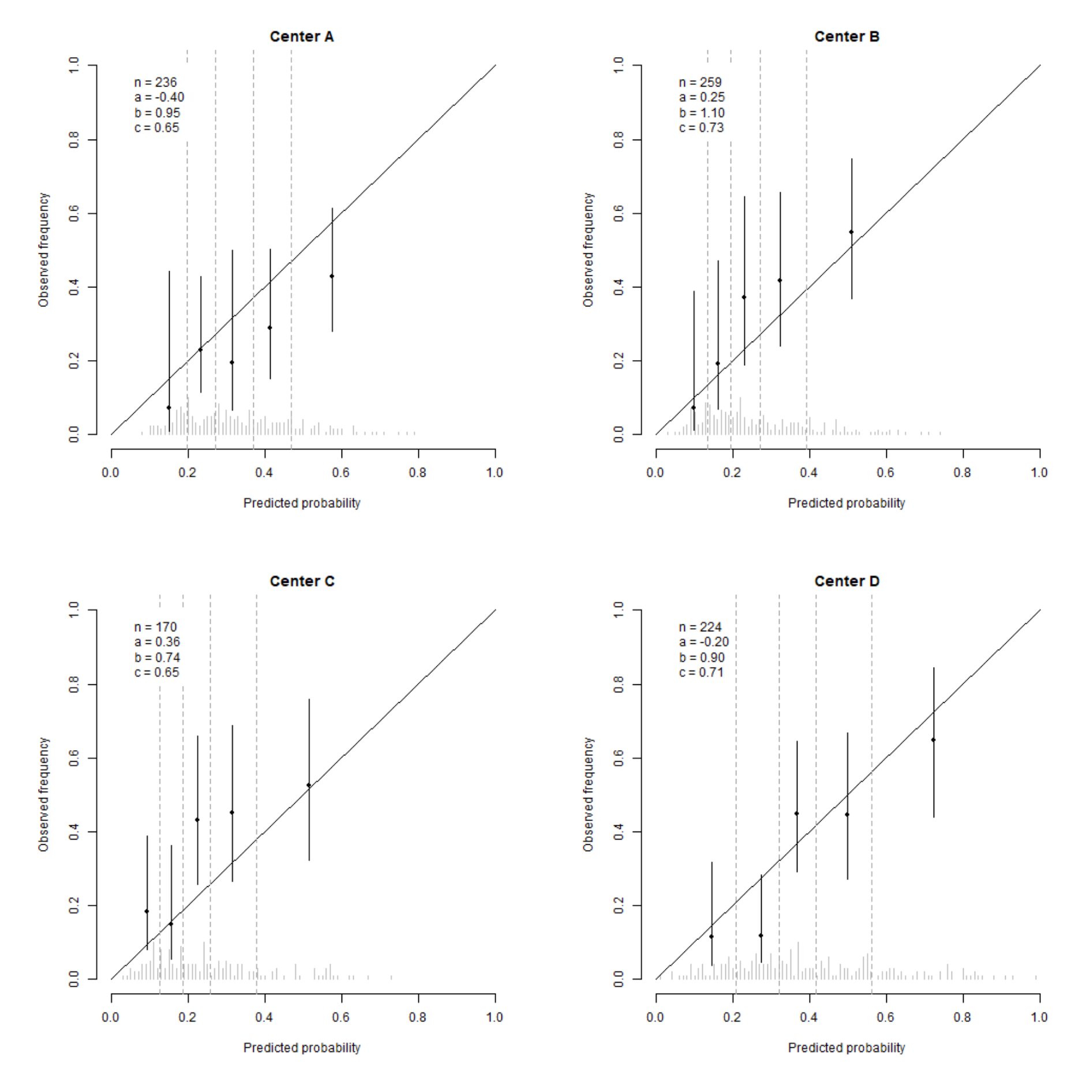

**Figure. Calibration curves of the final model predicting recurrence for each centre only for negative sentinel node patients obtained using leave-one-out internal-external validation.**

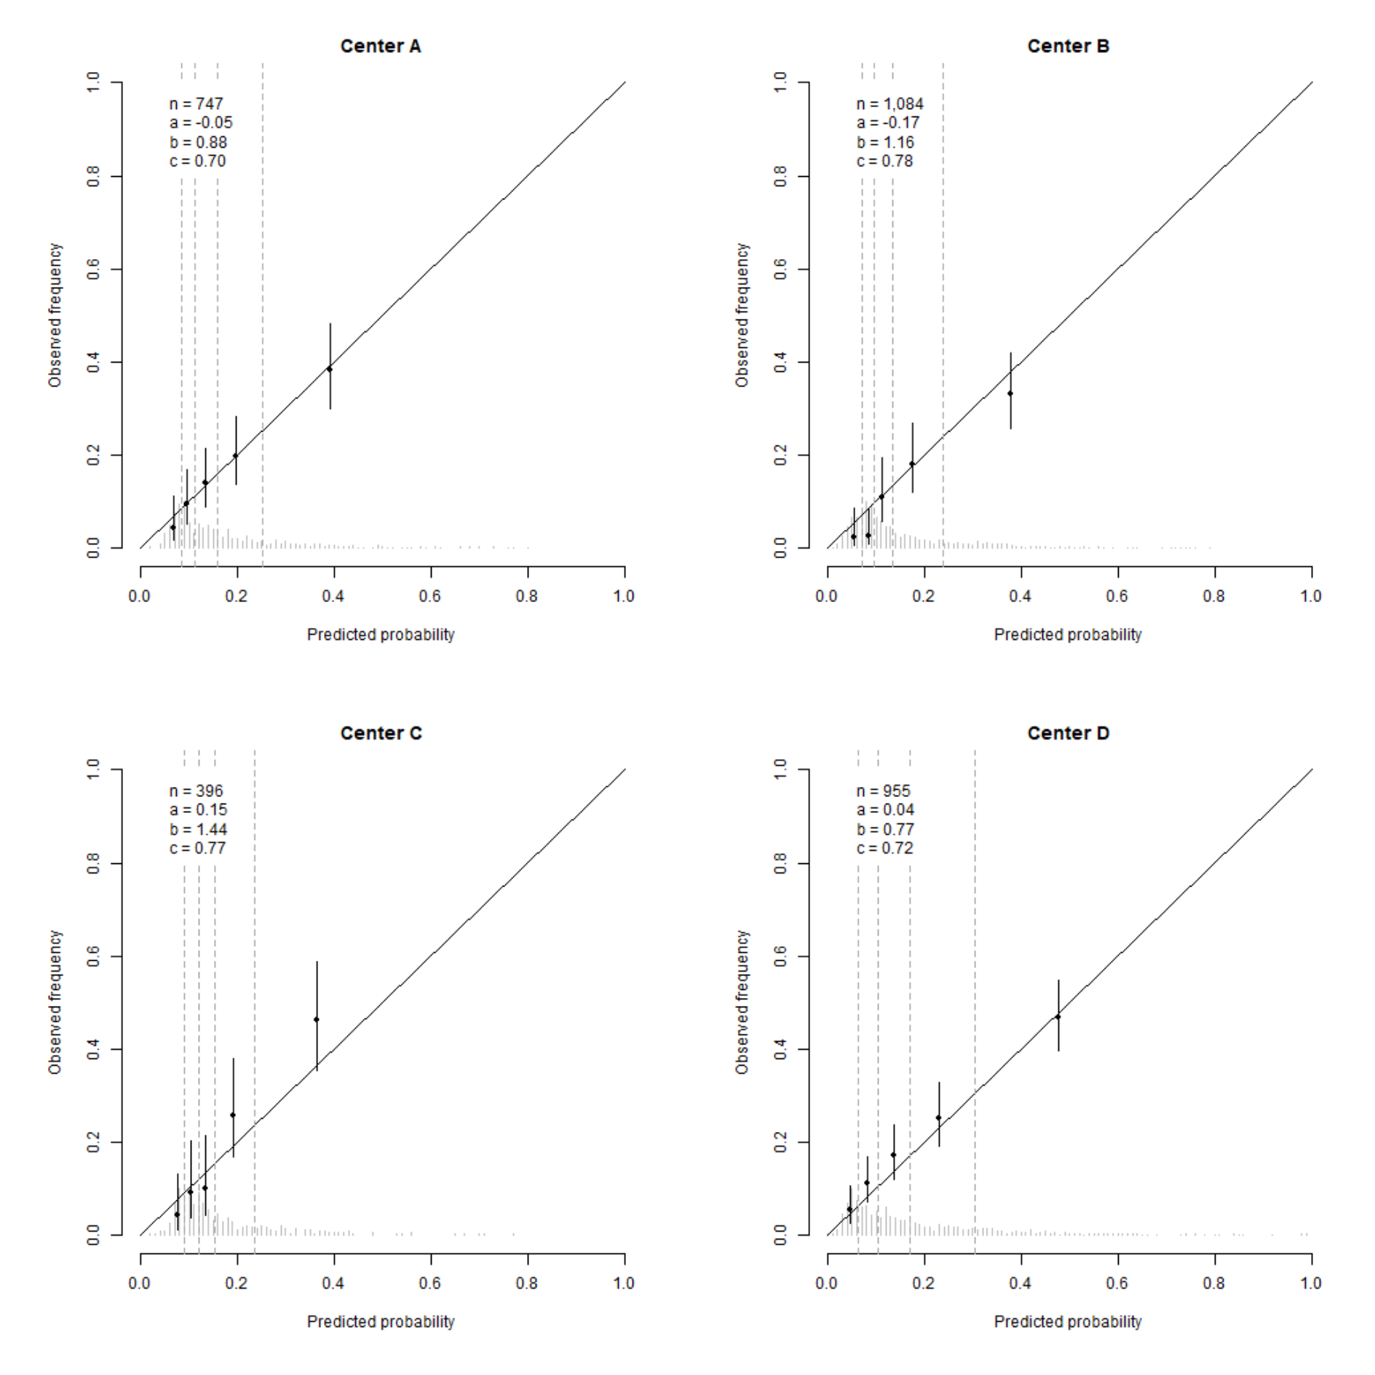

**Figure. Calibration curves of the final calibrated model predicting melanoma specific mortality for each centre only for negative sentinel node patients obtained using leave-one-out internal-external validation.**

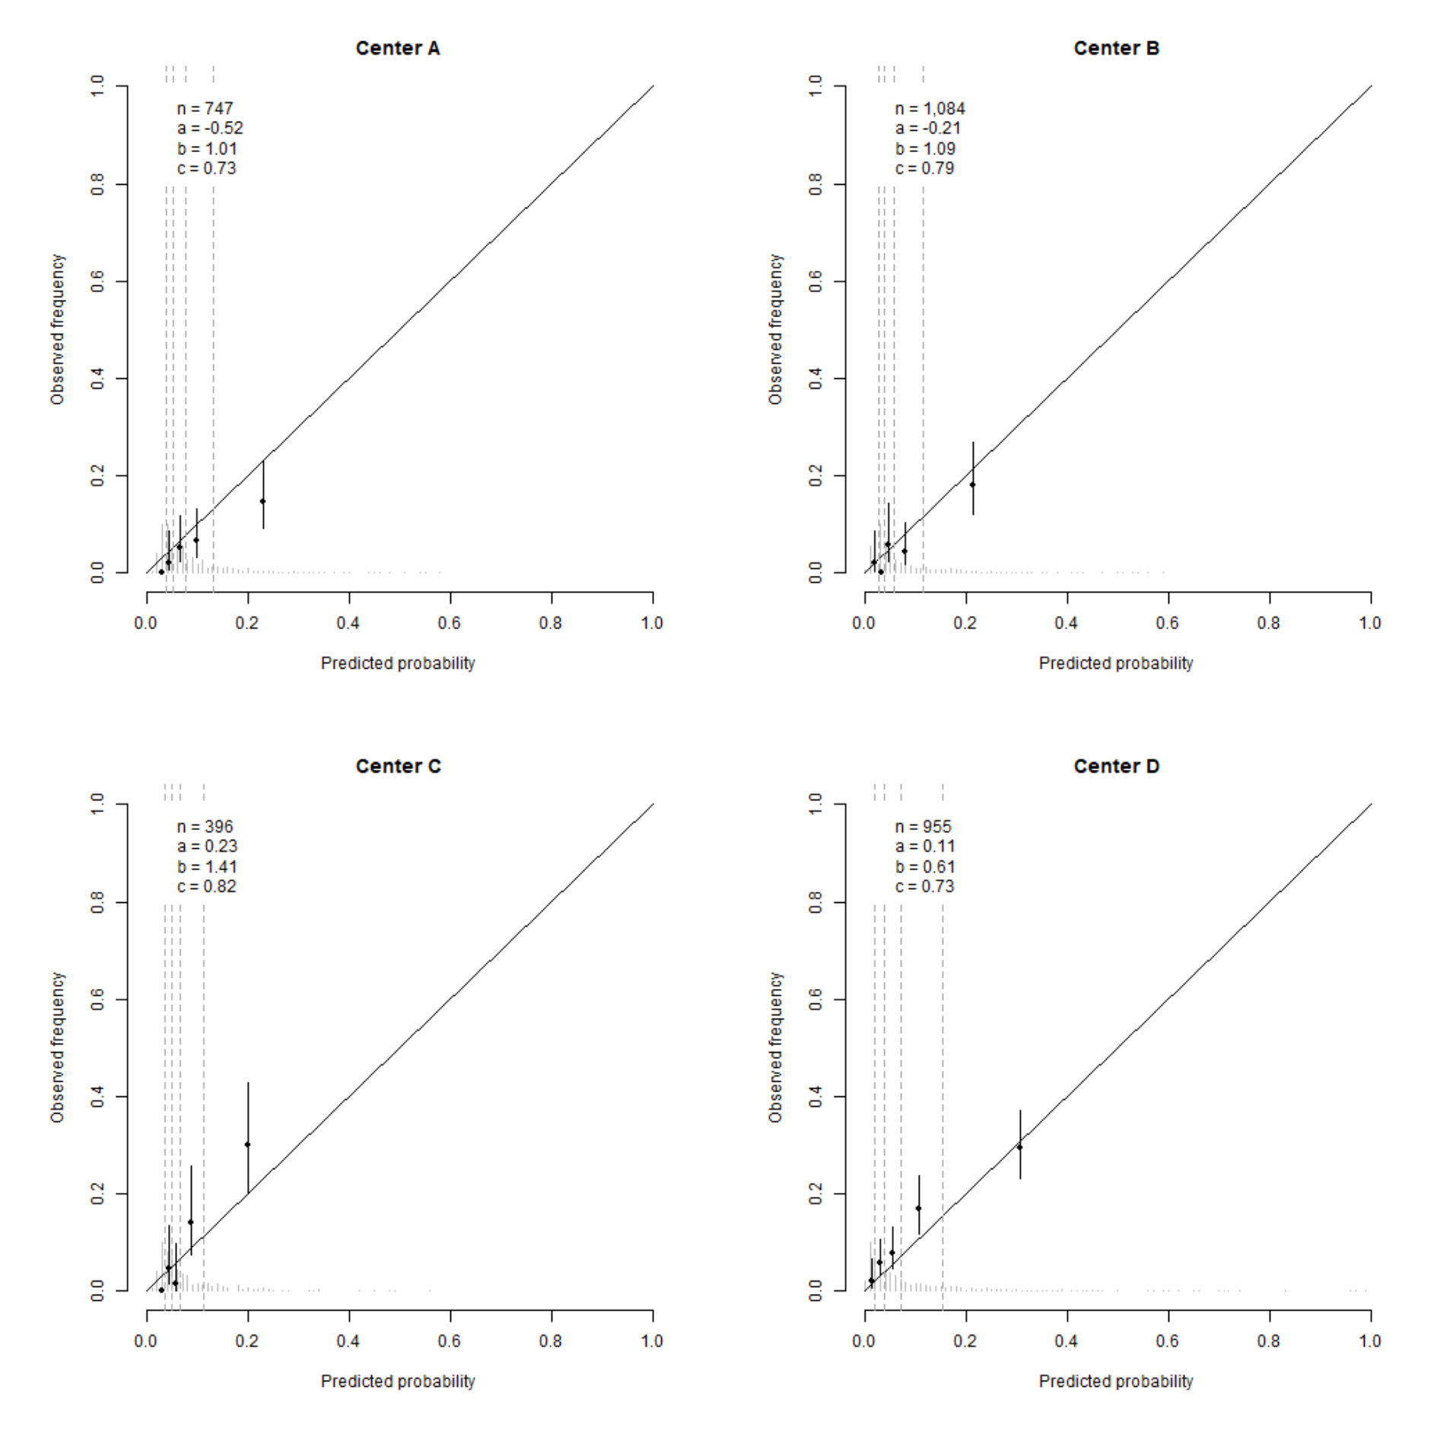

|  |  |  |  |  |  |  |  |  |  |
| --- | --- | --- | --- | --- | --- | --- | --- | --- | --- |
|  | **Model developed and fitted on European data** | | | |  | **Model developed on European data and fitted on pooled data** | | | |
|  | **Negative SN** | | **Positive SN** | |  | **Negative SN** | | **Positive SN** | |
|  | **HR** | **CI** | **HR** | **CI** |  | **HR** | **CI** | **HR** | **CI** |
| **Positive SN status1** |  |  | 2.93 | [2.44; 3.52] |  |  |  | 2.98 | [2.65; 3.34] |
| **Age**  (i.q.r. 66 versus 43 years) | 1.21 | [1.08; 1.35] | 1.21 | [1.08; 1.35] |  | 1.35 | [1.25; 1.45] | 1.35 | [1.25; 1.45] |
| **Ulceration** | 1.60 | [1.36; 1.88] | 1.60 | [1.36; 1.88] |  | 1.60 | [1.45; 1.77] | 1.60 | [1.45; 1.77] |
| **Location** |  |  |  |  |  |  |  |  |  |
| Arm | (ref) |  | (ref) |  |  | (ref) |  | (ref) |  |
| Leg | 1.30 | [0.99; 1.69] | 1.30 | [0.99; 1.69] |  | 1.45 | [1.23; 1.71] | 1.45 | [1.23; 1.71] |
| Trunk | 1.46 | [1.13; 1.88] | 1.46 | [1.13; 1.88] |  | 1.28 | [1.10; 1.50] | 1.28 | [1.10; 1.50] |
| Head and neck | 1.98 | [1.44; 2.72] | 1.98 | [1.44; 2.72] |  | 1.66 | [1.39; 1.98] | 1.66 | [1.39; 1.98] |
| **Breslow** **thickness**  (i.q.r. 3.5 versus 1.2 mm) | 2.57 | [2.26; 2.93] | 1.59 | [1.34; 1.88] |  | 2.15 | [1.97; 2.35] | 1.62 | [1.43; 1.83] |
| **SN tumour burden**  (i.q.r. 38 versus 0.01) |  |  | 5.15 | [2.51; 10.59] |  |  |  | 5.45 | [3.28; 9.06] |
| **Continent** |  |  |  |  |  | 1.15 | [1.05; 1.27] | 1.15 | [1.05; 1.27] |

1The hazard ratio of positive sentinel node patients includes the effects from the interaction terms.